Normalization In-Class Exercise
Question 1: The Public Safety office at Millennium College maintains a list of parking tickets issued to vehicles parked illegally on the campus. The table below shows a portion of this list for the fall semester.
ST I D | LName | FName | PhoneNo | St  Lic | LicNo | Ticket# | Date | Code | Fine
38249 | Brown | Thomas | 111-7804 | FL | BRY 123 | 15634 | 10/17/10 | 2 | $25
 |  |  |  |  |  | 16017 | 11/13/10 | 1 | $15
82453 | Green | Sally | 391-1689 | AL | TRE 141 | 14987 | 10/05/10 | 3 | $100
 |  |  |  |  |  | 16293 | 11/18/10 | 1 | $15
 |  |  |  |  |  | 17892 | 12/13/10 | 2 | $25

a). Convert this table to a relation in first normal from by entering appropriate data in the table. What are the determinants in this relation?
ST I D | LName | FName | PhoneNo | St  Lic | LicNo | Ticket# | Date | Code | Fine
38249 | Brown | Thomas | 111-7804 | FL | BRY 123 | 15634 | 10/17/10 | 2 | $25
38249 | Brown | Thomas | 111-7804 | FL | BRY 123 | 16017 | 11/13/10 | 1 | $15
82453 | Green | Sally | 391-1689 | AL | TRE 141 | 14987 | 10/05/10 | 3 | $100
82453 | Green | Sally | 391-1689 | AL | TRE 141 | 16293 | 11/18/10 | 1 | $15
82453 | Green | Sally | 391-1689 | AL | TRE-141 | 17892 | 12/13/10 | 2 | $25

The determinants are: ST I D , Ticket#, Code.

b). Draw a functional dependency diagram that shows all functional dependencies in the relation, based on the sample data shown.
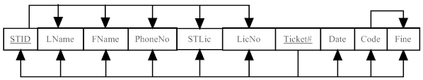
c). Develop a set of relations in third normal form. Include a new column with the heading Violation in the appropriate table to explain the reason for each ticket. Values in this column are: expired parking meter (ticket code 1), no parking permit (ticket code 2), and handicap violation (ticket code 3).
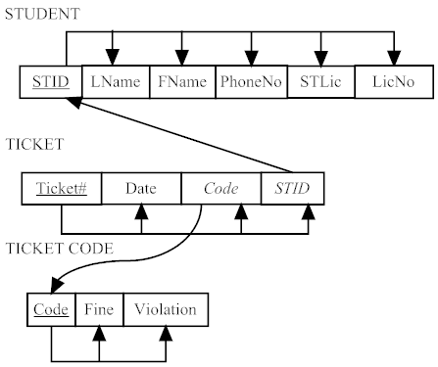

Question 2: Explore the data included in the table below. Assume that the primary key of this relation consists of two components: Author’s ID (AID) and Book number (BNbr). The relation includes data regarding authors, books, and publishers. In addition, it tells what an individual author’s per book royalty amount if in the case of multi-authored books.
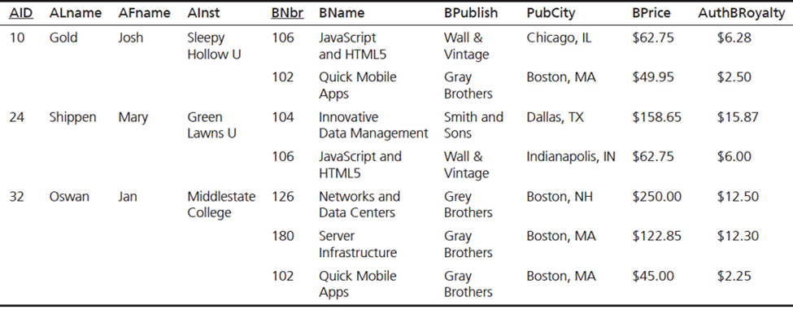
Identify the functional dependencies between the attributes, and then convert the relation into the third normal form.
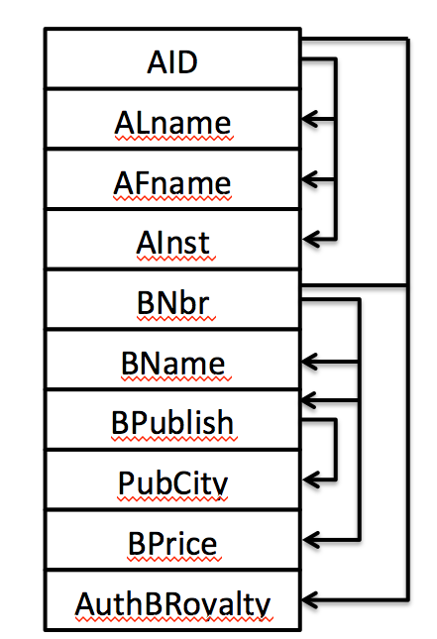 | AUTHORBOOKROYALTY(A I D , BNbr, AuthBRoyalty)  AUTHOR(A I D , ALName, AFName, AInst)  BOOK(BNbr, BName, BPublish, BPrice)  PUBLISHER(BPublish, PubCity)

